
LARCHES AND SAVICK SPORTS & EDUCATION CENTRE
CHILD PROTECTION AND SAFEGUARDING POLICY STATEMENT
SEPTEMBER 2024
This statement sets out LSEC’s approach to safeguarding and promoting the welfare of children and vulnerable adults. It applies to all aspects of our work and to everyone representing LSEC, including permanent and temporary employees, volunteers, contractors and self-employed staff.
At LSEC, we believe that everyone has a responsibility to promote the welfare of all children and adults, to keep them safe and to practice in a way that protects them.
We will make sure that all children and young people have the same protection regardless of age, disability, sex, race, religion, belief, or sexual orientation.
Safeguarding children is defined in ‘Keeping Children Safe in Education’ as:
- providing help and support to meet the needs of children as soon as problems emerge
- protecting children from maltreatment, whether that is within or outside the home, including online
- preventing the impairment of children’s mental and physical health or development
- ensuring that children grow up in circumstances consistent with the provision of safe and effective care
- taking action to enable all children to have the best outcomes.

As an alternative provider of education, LSEC acknowledges that the school on which a pupil is on roll will remain responsible for a pupil’s welfare during their time at LSEC. As such, LSEC will provide schools with written confirmation (Appendix 2) that LSEC has conducted all relevant safeguarding checks on staff and have clear policies and procedures in place regarding safeguarding and attendance.

SAFER RECRUITMENT
LSEC carries out safer recruitment checks on everyone who works for/on behalf of the organisation. All roles require:
- Verification of identity
- Right to work in the UK checks
- Enhanced Disclosure and Barring Service (DBS) check with Barred List check for those in regulated Activity.

INDUCTION AND TRAINING
All LSEC representatives are required to complete an induction and access regular training to ensure they have an understanding of safeguarding and safe practice relevant to their role. All employees will demonstrate in their practice their understanding of the following documents:
- Keeping Children Safe in Education
- Guidance for Safer Working Practice

CONDUCT
All LSEC representatives are expected to conduct themselves in a professional manner at all times and must adhere to the organisation’s Code of Conduct at all times.

RESPONDING TO CHILD PROTECTION AND SAFEGUARDING CONCERNS
LSEC staff should never investigate concerns about individual children who are suspected to be at risk or may be being abused, neglected or exploited. All staff have a responsibility to recognise concerns about children and respond proportionately and in accordance with KCSIE.

Where there is a safeguarding concern about a child;
- This will be reported to LSEC Designated Safeguarding Lead (DSL) using the Record of Concern Form (Appendix 1).
- This must be done without delay and without exception on the same working day that the concern was noticed.
Where the safeguarding concern is related to a member of staff:
- This will be reported to LSEC DSL.
- In the event that the concern is about LSEC DSL, the LSEC Deputy DSL (DDSL) and/or LSEC Manager will be informed, and advice will be sought from the LADO.
- This must be done without delay and without exception on the same working day that the concern was noticed.

LSEC DSL will assess the nature and level of the concern and decide on an appropriate course of action, in accordance with KCSIE and taking advice from relevant agencies when required.
Child protection and safeguarding concerns will be shared with the school DSL in a timely manner as the school remains responsible for safeguarding and protection of pupils on their roll. The school will therefore be best placed to respond to concerns by:
- managing any support for the child internally via the school’s own pastoral support processes; or,
- undertaking an early help assessment; or,
- making a referral for statutory services, for example as the child might be in need, is in need or suffering or likely to suffer harm.

If anyone is concerned that a child is at risk of immediate harm:
- LSEC DSL must be informed without delay. Record of Concern Form must be completed as soon as possible thereafter.
- LSEC DSL will phone the police on 999 and/or refer to the relevant Children’s Social Care department.
- LSEC DSL will inform the school DSL as soon as possible.
- In the event that LSEC DSL/DDSL is not available, action must still be taken without delay and any LSEC representative must;
  - Phone the police on 999.
  - Inform the LSEC DSL/DDSL as soon as possible.
  - Complete Record of Concern Form.

CONTACT DETAILS:
LSEC DSL: Jimmy Moon 07552 714739
LSEC DDSL: Nitesh Maru 07531 882507
LSEC MANAGER: Paul Wallace 07876 135356
Larches Sports and Education Centre 01772 385371

LANCASHIRE LADO: 01772 536 694 Local Authority Designated Officer (LADO) - Lancashire County Council
LANCASHIRE CSC: 0300 123 6720 or out of hours 0300 123 6722.
SCHOOLS SAFEGUARDING SUPPORT LINE: 01254 660584
USE THIS LINK FOR NON-LANCASHIRE CSC CONTACT DETAILS:
Report child abuse to a local council - GOV.UK (www.gov.uk)

LARCHES AND SAVICK SPORTS & EDUCATION CENTRE
CHILD PROTECTION AND SAFEGUARDING POLICY STATEMENT
APPENDIX 1: RECORD OF CONCERN FORM
Record of Safeguarding Concern
Pupil Name:
Date of concern: |  | Time of concern:
Details of my concern:
Be factual and specific.
My actions:
Staff Name:
Signature: |  | Date:
DSL Use Only
DSL Name:
Action:
Signature: |  | Date:
Feedback or Follow Up:

LARCHES AND SAVICK SPORTS & EDUCATION CENTRE
CHILD PROTECTION AND SAFEGUARDING POLICY STATEMENT
APPENDIX 2: LETTER OF ASSURANCE
SEPTEMBER 2024

FAO School Designated Safeguarding Lead,
Larches and Savick Sports & Education Centre (LSEC) is committed to safeguarding and promoting the welfare of children and young people and expects all staff to share this commitment. We therefore provide you with this letter to confirm that all relevant safeguarding checks on staff have been conducted and that we have clear policies and procedures in place regarding safeguarding.
- Disclosure and Barring Service (DBS)
All staff members have provided proof of an Enhanced DBS check and Barred List Check where required. Any disclosures on the DBS certificate are risk assessed.

- Identity
All representatives of LSEC have had their identity verified.

- Right to work in the UK
All staff members have been checked in line with Home Office guidelines to ensure they have the right to work in the UK.

- Safeguarding Induction and Training
All staff members undergo a safeguarding induction and access safeguarding training relevant to their role, at least annually. All staff have read and understood at least Part One of Keeping Children Safe in Education. LSEC DSL and DDSL undergo DSL Training every two years.

- Safeguarding Policies
LSEC will adhere to the principles of the relevant school’s safeguarding policies. In addition to this all staff adhere to the LSEC Child Protection and Safeguarding Policy Statement. This document is reviewed and updated at least annually.

Please retain a copy of this letter of assurance and Child Protection and Safeguarding Policy Statement for your records. This will be updated annually.

Kindest regards,

Jimmy Moon
LSEC DSL
01772 385371

LARCHES AND SAVICK SPORTS & EDUCATION CENTRE
CHILD PROTECTION AND SAFEGUARDING POLICY STATEMENT
APPENDIX 3: USE OF REASONABLE FORCE

The term ‘reasonable force’ covers the broad range of actions used by most teachers at some point in their career that involve a degree of physical contact with pupils.
Force is usually used either to control or restrain. This can range from guiding a pupil to safety by the arm through to more extreme circumstances such as breaking up a fight or where a student needs to be restrained to prevent violence or injury.
‘Reasonable in the circumstances’ means using no more force than is needed.
Reasonable force is generally used to control pupils and to restrain them.
- Control means either passive physical contact, such as standing between pupils or blocking a pupil's path, or active physical contact such as leading a pupil by the arm out of a classroom.
- Restraint means to hold back physically or to bring a pupil under control. It is typically used in more extreme circumstances, for example when two pupils are fighting and refuse to separate without physical intervention.
LSEC staff should always try to avoid acting in a way that might cause injury, but in extreme cases it may not always be possible to avoid injuring the pupil. The following guidelines should always be adhered to:
- Never work against the body, always work with the body (i.e. they always move body parts in the direction they would naturally move rather than bending limbs or fingers away from the joint).
- Never put arms across the child’s chest area.
- Never physically restrain a child by putting arms around them – e.g. restricting all their arm movement.
- No touching of knees or ankles.
Reasonable force can be used to prevent pupils:
- from hurting themselves
- from hurting others
- from damaging property
- or from causing disorder.
The decision on whether or not to physically intervene is down to the professional judgement of the staff member concerned and should always depend on the individual circumstances.
It is unlawful to use any type of force as a punishment – LSEC staff must NEVER use force as a punishment.
LSEC staff will make reasonable adjustments for disabled children and children with special educational needs (SEN) when considering and/or using reasonable force. This will be based on the individual situation and an understanding of the needs of the pupil concerned.
When reasonable force has been used, the staff member will inform the DSL as soon as possible. A factual record of the incident will be recorded by the staff member/s involved using the ‘Record of Concern Form’ (Appendix 1).
LSEC will have due regard for the DfE Guidance: Use of reasonable force 2013
LARCHES AND SAVICK SPORTS & EDUCATION CENTRE
CHILD PROTECTION AND SAFEGUARDING POLICY STATEMENT
APPENDIX 4: STAFF CONDUCT
We all have the right to:
- Work in an atmosphere of mutual respect
- Be treated fairly
- Be listened to and for views to be respected
- Be valued for the efforts and strengths of the work undertaken and to receive support for those areas that need developing
- Work in a clean, safe, secure and well organised workplace
- Be kept appropriately informed through open channels of communication
We all therefore have a responsibility to:
- Put children at the centre of all that we do
- Separate personal and professional lives by creating clearly defined boundaries
- Challenge prejudice in the workplace and support colleagues of all social, cultural and ethnic backgrounds
- Listen to and respect the opinions of others
- Support the development of others
- Promote positive relationships with schools and other organisations
- Safeguard the emotional and physical well-being of pupils
- Raise concerns in a non-threatening manner before they become a more serious problem
- Take responsibility for the working environment leaving it as others would wish to find it
- Challenge unprofessional behaviour in an appropriate and respectful manner
BEING A GOOD ROLE MODEL
All staff who work at LSEC must set examples of behaviour and conduct which can be modelled by pupils we work with.
- Staff must not use inappropriate or offensive language at any time.
- Staff must not exhibit behaviour that could be deemed inappropriate or offensive at any time.
- All staff must demonstrate the highest standards of conduct in order to encourage pupils to do the same.
- All staff must avoid putting themselves at risk of allegations of abusive or unprofessional conduct.
HONESTY AND INTEGRITY
Staff must maintain the highest standards of honesty and integrity in their work. This includes the handling and claiming of money.
- All staff must comply with the Bribery Act 2010. A person may be guilty of an offence of bribery under this act if they offer, promise or give financial advantage or other advantage to someone; or if they request, agree or accept or receive a bribe from another person.
- If you believe that a person has failed to comply with the Bribery Act, you should refer to the Whistleblowing procedure in the Staff Handbook.
CONFIDENTIALITY
Where staff have access to confidential information about colleagues, pupils or parents/carers, staff must not reveal such information except to those colleagues who have a professional role in relation to the individual.
DRESS AND APPEARANCE

A person’s dress and appearance are matters of personal choice and self-expression. Some individuals will wish to exercise their own cultural customs. However, staff should select a manner of dress and appearance appropriate to their professional role and which may be necessarily different to that adopted in their personal life.
- Staff should ensure they are dressed safely and appropriately for the tasks they undertake.
- Those who dress or appear in a manner which could be viewed as offensive or inappropriate will render themselves vulnerable to criticism or allegation.
- Staff should wear clothing which:
  - promotes a positive and professional image
  - is not likely to be viewed as offensive, revealing, or sexually provocative
  - does not distract, cause embarrassment or give rise to misunderstanding
  - is absent of any political or otherwise contentious slogans
  - is not considered to be discriminatory
CONDUCT OUTSIDE OF WORK
Staff must not engage in conduct outside work which could seriously damage the reputation and standing of the organisation or the employee’s own reputation or the reputation of other members of the organisation. Any such conduct could lead to dismissal. Criminal offences that involve violence or possession or use of illegal drugs or sexual misconduct are likely to be regarded as unacceptable and could lead to dismissal.
USE OF DEVICES, IT AND SOCIAL MEDIA
Staff must exercise caution when using information technology and be aware of the risks to themselves and others.
- Staff must not engage in inappropriate use of social network sites which may bring themselves, LSEC or the wider community into disrepute.
- Staff must only use their school email account for work purposes.
- Staff must not post on personal Social Media platforms during directed time.
- Staff must not engage in any contact with pupils via online or social media platforms.
- Staff must not use their personal devices during sessions with pupils. This includes the taking of images or recording of videos.
BRITISH VALUES
All staff are expected to uphold and promote the fundamental principles of British values, including democracy, the rule of law, individual liberty, mutual respect, and tolerance of those with different faiths and beliefs.

LARCHES AND SAVICK SPORTS & EDUCATION CENTRE
CHILD PROTECTION AND SAFEGUARDING POLICY STATEMENT
APPENDIX 5: ONLINE SAFETY
This policy applies to all LSEC staff members and pupils.
To ensure the online safeguarding of members of our Centre’s community it is important that all members of that community work together to develop safe and responsible online behaviours, reporting inappropriate online behaviours, concerns, and misuse as soon as these become apparent.
Internet access at LSEC is filtered for all users to protect pupils from accessing illegal, inappropriate and potentially harmful content.
Filtering Provider Checklist
However, all staff should monitor the use of devices, technology and the internet and report any such content to the DSL.
LSEC staff are responsible for ensuring that:
- They report any concerns about online safety to the DSL/Centre Manager using the ‘Record of Concern Form’ (Appendix 1)
- All digital communications with pupils and parents/carers should be on a professional level and only carried out using official school systems
- Online safety issues are embedded in all aspects of LSEC activities
- Pupils understand and follow online safety rules
- Monitoring pupils’ internet use whilst at the Centre and report any concerns to the DSL
- Where internet use is pre-planned, pupils should be guided to sites checked as suitable for their use and that processes are in place for dealing with any unsuitable material that is found in internet searches.
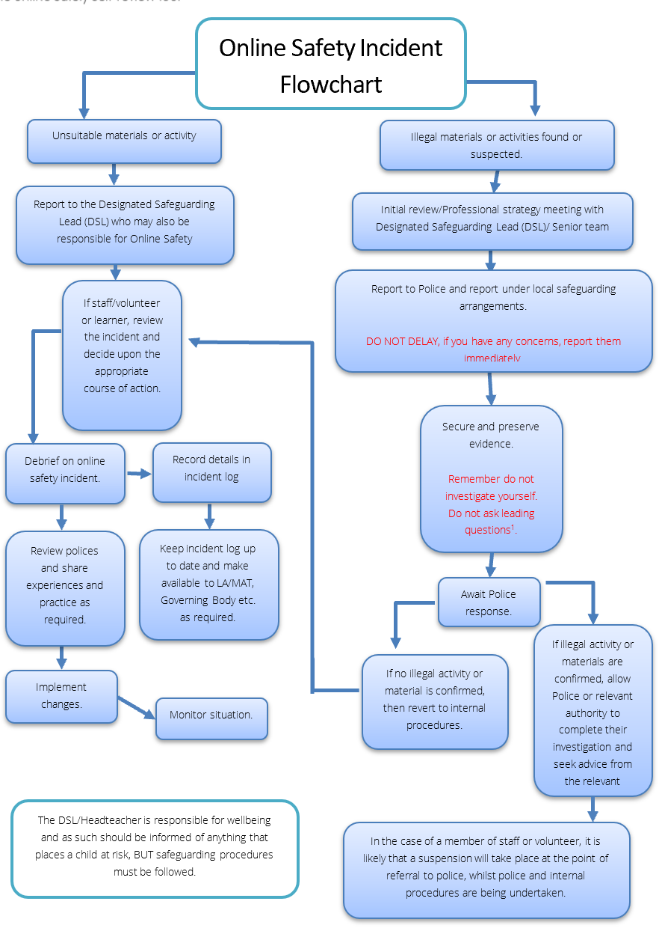
LARCHES AND SAVICK SPORTS & EDUCATION CENTRE
CHILD PROTECTION AND SAFEGUARDING POLICY STATEMENT
APPENDIX 6: LONE WORKING
This policy applies to all staff members working alone at LSEC.
Staff members who are likely to work alone include:
- Staff working early or late hours
- Staff working outside normal hours or when the centre is closed
- Staff in isolated areas of the centre
- Staff who transport pupils

Staff members working alone should carry a mobile phone, or another form of communication, and be able to easily contact a colleague in case of an emergency.
Staff members should be familiar with the emergency procedures in case of accidents, incidents, or security breaches. This includes knowing how to evacuate the premises if necessary.
A list of emergency contacts, including local emergency services, school security, and relevant staff members, will be readily accessible to all employees working alone.
Transporting Pupils
Drivers are responsible for their own vehicle’s roadworthiness and appropriateness for the task to be undertaken and their fitness to drive.
Drivers must ensure:
- That the vehicle insurance is current, fully comprehensive and insured for business use
- The vehicle has a current MOT certificate, is in a road worthy condition & is appropriate to transport pupils
- It is a legal requirement that all passengers wear seatbelts and the driver should ensure that they do so.
Staff should ensure that their behaviour is safe and that the transport arrangements and the vehicle meet all legal requirements.
Staff should never offer to transport pupils outside of their normal working duties, other than in an emergency or where not doing so would mean the child may be at risk.
Pupils should usually travel with a minimum of 2 appropriate adults whether travelling in a car or minibus, to ensure there is sufficient support in e.g. a medical or other emergency, car accident etc. Where this is not possible, the following guidelines should be adhered to:
- Driver has Enhanced DBS with Barred List Check.
- Pupils are aware of the purpose and nature of the journey and give consent.
- Parents are informed of journeys where pupils are only accompanied by one staff member.
- Pupil/s should be seated in the rear seats of the car, not the front passenger seat unless this is unavoidable.
- Driver should have access to charged mobile phone and emergency contact details
- Driver should record any safeguarding concerns that occur during the journey and report them to the DSL as soon as possible.
- Uphold LSEC Code of Conduct and conduct themselves in a professional manner at all times.
Refer to Guidance for Safer Working Practice

